CHAPTER 1
INTRODUCTION
1.1 Introduction to Picture Puzzle Game
The tremendous growth in electronic devices such as Mobile Phones, Personal Computers Laptops and the investment in the technology have resulted in such devices being used for various purposes. One such purpose is for playing games. Pervasive gaming is an emerging genre in which pre-computer traditional games are being played with computer functionality. Traditional board games such as Chess, Go and jigsaw puzzle that are now being played using computing technology offer a new and engaging gaming experiences to the players.
Picture puzzle is a puzzle that is made of a square-shaped image that has been broken up into smaller pieces and scrambled. The smaller pieces are usually in a square-shaped form. In order to reorganize the picture, the smaller pieces are slided which means that one piece is removed to allow for the movement of the pieces. Picture puzzle game applications are already available in the desktop environment and mobile environment.
Some traditional picture puzzle game applications use built-in images to create the puzzle. This is not going to be as challenging after the player has gotten used to the image and the application. In order to make picture puzzle game to be more interesting, some applications have the features that allow picture puzzle to be personalised. Players have to upload the image and the program will break the image into smaller pieces for the player to assemble to its original form.
The proposed development of personalised picture puzzle is also a picture puzzle game to create a puzzle that can be played but instead of just using existing stored images, the personalised capability allows the player to use the built-in camera phone to capture an image and use the newly captured image to create the puzzle. This game application can also be played using any existing images that are already stored in the mobile phone.

The player can also choose the level of difficulty of the puzzle and play against the time to solve the puzzle. These features together with the personalised capability give the player a more challenging way of playing the picture puzzle game. The image that is taken is displayed as a scrambled grid and the player is required to scramble the image to start the game.
There are numerous picture puzzle game applications in the market that allow personalised images to be used. An example of a picture puzzle games in a desktop environment is Picture Puzzle Wizard, a freeware picture puzzle wizard developed by VSI Systems. This application allows the player to upload any bitmap images to create a new game. However, the application does not come with features that are normally available in a game. The game application does not provide the player with scores after each game. Player also cannot set the level of difficulty for a particular game.
All-Star Puzzles is another company that offers personalised picture puzzle to its player. All-Star Puzzle requires the player to upload the images to the company’s server. The image sent cannot exceed 250 KB in size, cannot be wider than or taller than 700 pixels but must be wider than and taller than 100 pixels. At the end of process, All-Star Puzzle will provide a URL address to the player and the player can share the URL address with other players.The All-Star Puzzle is active for at least one month after it has been created.
Mix Pix is an example of another personalised picture puzzle game and it is developed by Nokia Corporation. This Javabased game is pre-installed in some Nokia mobile phones. The application allows captured images to be used as the image for the puzzle. In this application however, the player is not allowed to select a timer. Player is able to complete a puzzle without being confined to a specific time range. Mix Pix also does not provide the capability to view the solved puzzle as a hint to the player. Mobile games can also be developed using Macromedia Flash Lite. Omega Mobile is a company that develops mobile applications using Macromedia Flash products [9]. Examples of the picture puzzles developed by Omega Mobile are Dogs Puzzle Pix, Cats Puzzle Pix and Cars Puzzle Pix. The images used in these applications cannot be personalised. These picture puzzle game applications have a hint function that allows the player to identify the correct puzzle piece at a selected position.

Chapter 2
SOFTWARE AND HARDWARE SPECIFICATION
The Picture Puzzle Game makes use of various software and hardware for its design. It makes use of present technologies and tools for making it easier for better performance and also to improve the efficiency of the overall system.
2.1 OVERVIEW
A puzzle is a game, problem, or toy that tests a person's ingenuity or knowledge. In a puzzle, the solver is expected to put pieces together in a logical way, in order to arrive at the correct or fun solution of the puzzle.
Picture Puzzle is a game application where the player use existing images stored in the mobile phone to create a puzzle to be played. This traditional picture puzzle is not so challenging once the player is familiar with the game. The objective of the developed game application is to have a similar game application that can provide the player with more challenging gaming experience. The developed game application is also a picture puzzle game application to create a puzzle to be played but instead of just using existing images that are stored, the personalised capability allows the player to use the built-in camera phone to capture an image and use the newly captured image to create the puzzle.
Rather than presenting a random collection of puzzles to solve, puzzle games typically offer a series of related puzzles that are a variation on a single theme. These games usually have a simple set of rules, where players manipulate game pieces on a grid, network or other interaction space.
Typically, games are considered as a way of seeking entertainment. However, puzzle games not only entertain but exercise the brain increasing its ability to learn and grow intelligently. As puzzles help increase the brain functions, use of puzzles for educating children or adults can prove to be a fruitful attempt.

2.2 SPECIFIC REQUIREMENT
Any system design requires tools and technologies for its easy and efficient performance. Below are the specification of software and hardware that has been used for the design and implementation of the Picture Puzzle Game.
2.2.1 SOFTWARE REQUIREMENTS
For the front end MICROSOFT VISUAL STUDIO 2010 is used which helps to create a web pages as per the requirement of the project. The code is written as per the buttons and links created in the front end.
- Operating System : Window 10
- Front End : Microsoft Visual Studio 2010
- Programming Language : C#

2.2.2 HARDWARE REQUIREMENTS
Similar to that of software requirements there are some hardware requirements that is essential for the operation of the Picture Puzzle Game. A processor of core i5 is used for this system development. Memory is needed for the execution at the front end.
- Processor :i5 processor or higher version
- Ram :1 GB or more
- Hard Disk Free Space :5GB

CHAPTER 3
PICTURE PUZZLE GAME DESIGN
3.1 Flowchart for Generation:
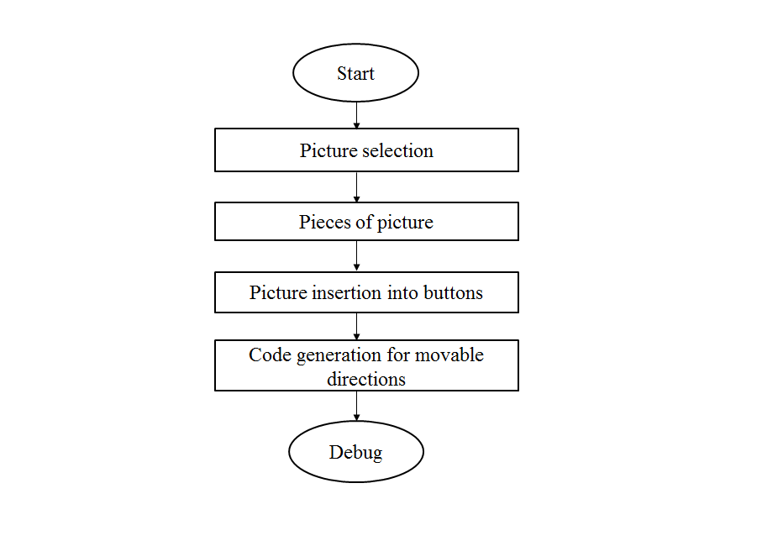
Figure 3.1: Figure show the flowchart for generation of Picture Puzzle Game.

3.2 Flowchart for Implementation:
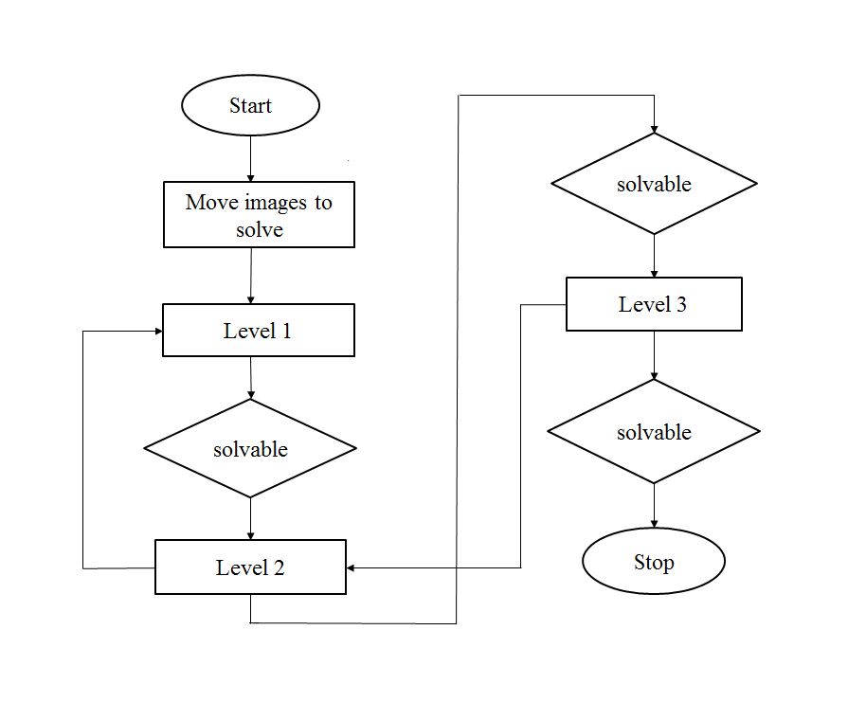Figure 3.2: Figure show the flowchart for implementation for Picture Puzzle Game

CHAPTER 4
IMPLEMENTATION
4.1 C# Code for the Implementation of 3*3 Picture Puzzle Game

using System;
using System.Collections.Generic;
using System.ComponentModel;
using System.Data;
using System.Drawing;
using System.Linq;
using System.Text;
using System.Windows.Forms;

namespace puzzle
{
public partial class Form1 : Form
{
public Form1()
{
InitializeComponent();
}

private void Form1_Load(object sender, EventArgs e)
{
button1.BackColor = Color.Gray;
button2.BackColor = Color.Gray;
button3.BackColor = Color.Gray;
button4.BackColor = Color.Gray;
button5.BackColor = Color.Gray;
button6.BackColor = Color.Gray;
button7.BackColor = Color.Gray;
button8.BackColor = Color.Gray;
button9.BackColor = Color.White;
button1.Image = Properties.Resources.f3;
button2.Image = Properties.Resources.f1;
button3.Image = Properties.Resources.f5;
button4.Image = Properties.Resources.f7;
button5.Image = Properties.Resources.f2;
button6.Image = Properties.Resources.f8;
button7.Image = Properties.Resources.f4;
button8.Image = Properties.Resources.f6;
button9.Image = Properties.Resources.f0;
button11.Image = Properties.Resources.ff;

}

private void button1_Click(object sender, EventArgs e)
{

if (button2.BackColor == Color.White)
{
button2.Image = button1.Image;
button2.BackColor = Color.Gray;
button1.Image = Properties.Resources.f0;
button1.BackColor = Color.White;
}
if (button4.BackColor == Color.White)
{
button4.Image = button1.Image;
button4.BackColor = Color.Gray;
button1.Image = Properties.Resources.f0;
button1.BackColor = Color.White;
}
}

private void button2_Click(object sender, EventArgs e)
{
if (button1.BackColor == Color.White)
{
button1.Image = button2.Image;
button1.BackColor = Color.Gray;
button2.Image = Properties.Resources.f0;
button2.BackColor = Color.White;
}
if (button3.BackColor == Color.White)
{
button3.Image = button2.Image;
button3.BackColor = Color.Gray;
button2.Image = Properties.Resources.f0;
button2.BackColor = Color.White;
}
if (button5.BackColor == Color.White)
{
button5.Image = button2.Image;
button5.BackColor = Color.Gray;
button2.Image = Properties.Resources.f0;
button2.BackColor = Color.White;
}
}

private void button3_Click(object sender, EventArgs e)
{
if (button2.BackColor == Color.White)
{
button2.Image = button3.Image;
button2.BackColor = Color.Gray;
button3.Image = Properties.Resources.f0;
button3.BackColor = Color.White;
}
if (button6.BackColor == Color.White)
{
button6.Image = button3.Image;
button6.BackColor = Color.Gray;
button3.Image = Properties.Resources.f0;
button3.BackColor = Color.White;
}
}

private void button4_Click(object sender, EventArgs e)
{
if (button1.BackColor == Color.White)
{
button1.Image = button4.Image;
button1.BackColor = Color.Gray;
button4.Image = Properties.Resources.f0;
button4.BackColor = Color.White;
}

if (button5.BackColor == Color.White)
{
button5.Image = button4.Image;
button5.BackColor = Color.Gray;
button4.Image = Properties.Resources.f0;
button4.BackColor = Color.White;
}
if (button7.BackColor == Color.White)
{
button7.Image = button4.Image;
button7.BackColor = Color.Gray;
button4.Image = Properties.Resources.f0;
button4.BackColor = Color.White;
}
}

private void button5_Click(object sender, EventArgs e)
{
if (button2.BackColor == Color.White)
{
button2.Image = button5.Image;
button2.BackColor = Color.Gray;
button5.Image = Properties.Resources.f0;
button5.BackColor = Color.White;
}
if (button4.BackColor == Color.White)
{
button4.Image = button5.Image;
button4.BackColor = Color.Gray;
button5.Image = Properties.Resources.f0;
button5.BackColor = Color.White;
}
if (button6.BackColor == Color.White)
{
button6.Image = button5.Image;
button6.BackColor = Color.Gray;
button5.Image = Properties.Resources.f0;
button5.BackColor = Color.White;
}
if (button8.BackColor == Color.White)
{
button8.Image = button5.Image;
button8.BackColor = Color.Gray;
button5.Image = Properties.Resources.f0;
button5.BackColor = Color.White;
}
}

private void button6_Click(object sender, EventArgs e)
{
if (button3.BackColor == Color.White)
{
button3.Image = button6.Image;
button3.BackColor = Color.Gray;
button6.Image = Properties.Resources.f0;
button6.BackColor = Color.White;
}

if (button5.BackColor == Color.White)
{
button5.Image = button6.Image;
button5.BackColor = Color.Gray;
button6.Image = Properties.Resources.f0;
button6.BackColor = Color.White;
}
if (button9.BackColor == Color.White)
{
button9.Image = button6.Image;
button9.BackColor = Color.Gray;
button6.Image = Properties.Resources.f0;
button6.BackColor = Color.White;
}
}

private void button7_Click(object sender, EventArgs e)
{
if (button4.BackColor == Color.White)
{
button4.Image = button7.Image;
button4.BackColor = Color.Gray;
button7.Image = Properties.Resources.f0;
button7.BackColor = Color.White;
}
if (button8.BackColor == Color.White)
{
button8.Image = button7.Image;
button8.BackColor = Color.Gray;
button7.Image = Properties.Resources.f0;
button7.BackColor = Color.White;
}
}

private void button8_Click(object sender, EventArgs e)
{
if (button5.BackColor == Color.White)
{
button5.Image = button8.Image;
button5.BackColor = Color.Gray;
button8.Image = Properties.Resources.f0;
button8.BackColor = Color.White;
}
if (button7.BackColor == Color.White)
{
button7.Image = button8.Image;
button7.BackColor = Color.Gray;
button8.Image = Properties.Resources.f0;
button8.BackColor = Color.White;
}
if (button9.BackColor == Color.White)
{
button9.Image = button8.Image;
button9.BackColor = Color.Gray;
button8.Image = Properties.Resources.f0;
button8.BackColor = Color.White;
}
}

private void button9_Click(object sender, EventArgs e)
{
if (button6.BackColor == Color.White)
{
button6.Image = button9.Image;
button6.BackColor = Color.Gray;
button9.Image = Properties.Resources.f0;
button9.BackColor = Color.White;
}
if (button8.BackColor == Color.White)
{
button8.Image = button9.Image;
button8.BackColor = Color.Gray;
button9.Image = Properties.Resources.f0;
button9.BackColor = Color.White;
}
}

private void button10_Click(object sender, EventArgs e)
{
Form2 a = new Form2();
a.Show();
this.Hide();
}

}
}

4.2 C# code for the Implementation of 4*4 Picture Puzzle Game
using System;
using System.Collections.Generic;
using System.ComponentModel;
using System.Data;
using System.Drawing;
using System.Linq;
using System.Text;
using System.Windows.Forms;

namespace puzzle
{
public partial class Form2 : Form
{
public Form2()
{
InitializeComponent();
}

private void Form2_Load(object sender, EventArgs e)
{
button1.BackColor = Color.Gray;
button2.BackColor = Color.Gray;
button3.BackColor = Color.Gray;
button4.BackColor = Color.Gray;
button5.BackColor = Color.Gray;
button6.BackColor = Color.Gray;
button7.BackColor = Color.Gray;
button8.BackColor = Color.Gray;
button9.BackColor = Color.Gray;
button13.BackColor = Color.Gray;
button14.BackColor = Color.Gray;
button15.BackColor = Color.Gray;
button16.BackColor = Color.Gray;
button17.BackColor = Color.Gray;
button18.BackColor = Color.Gray;
button19.BackColor = Color.White;
button1.Image = Properties.Resources.c13;
button2.Image = Properties.Resources.c1;
button3.Image = Properties.Resources.c5;
button4.Image = Properties.Resources.c7;
button5.Image = Properties.Resources.c2;
button6.Image = Properties.Resources.c8;
button7.Image = Properties.Resources.c4;
button8.Image = Properties.Resources.c9;
button9.Image = Properties.Resources.c14;
button13.Image = Properties.Resources.c11;
button14.Image = Properties.Resources.c15;
button15.Image = Properties.Resources.c12;
button16.Image = Properties.Resources.c6;
button17.Image = Properties.Resources.c3;
button18.Image = Properties.Resources.c10;
button19.Image = Properties.Resources.c0;
button10.Image = Properties.Resources.cc;

}

private void button1_Click(object sender, EventArgs e)
{
if (button2.BackColor == Color.White)
{
button2.Image = button1.Image;
button2.BackColor = Color.Gray;
button1.Image = Properties.Resources.c0;
button1.BackColor = Color.White;
}
if (button5.BackColor == Color.White)
{
button5.Image = button1.Image;
button5.BackColor = Color.Gray;
button1.Image = Properties.Resources.c0;
button1.BackColor = Color.White;
}
}

private void button2_Click(object sender, EventArgs e)
{
if (button1.BackColor == Color.White)
{
button1.Image = button2.Image;
button1.BackColor = Color.Gray;
button2.Image = Properties.Resources.c0;
button2.BackColor = Color.White;
}
if (button3.BackColor == Color.White)
{
button3.Image = button2.Image;
button3.BackColor = Color.Gray;
button2.Image = Properties.Resources.c0;
button2.BackColor = Color.White;
}
if (button6.BackColor == Color.White)
{
button6.Image = button2.Image;
button6.BackColor = Color.Gray;
button2.Image = Properties.Resources.c0;
button2.BackColor = Color.White;
}
}

private void button3_Click(object sender, EventArgs e)
{
if (button2.BackColor == Color.White)
{
button2.Image = button3.Image;
button2.BackColor = Color.Gray;
button3.Image = Properties.Resources.c0;
button3.BackColor = Color.White;
}
if (button4.BackColor == Color.White)
{
button4.Image = button3.Image;
button4.BackColor = Color.Gray;
button3.Image = Properties.Resources.c0;
button3.BackColor = Color.White;
}

if (button7.BackColor == Color.White)
{
button7.Image = button3.Image;
button7.BackColor = Color.Gray;
button3.Image = Properties.Resources.c0;
button3.BackColor = Color.White;
}
}

private void button4_Click(object sender, EventArgs e)
{
if (button3.BackColor == Color.White)
{
button3.Image = button4.Image;
button3.BackColor = Color.Gray;
button4.Image = Properties.Resources.c0;
button4.BackColor = Color.White;
}
if (button8.BackColor == Color.White)
{
button8.Image = button4.Image;
button8.BackColor = Color.Gray;
button4.Image = Properties.Resources.c0;
button4.BackColor = Color.White;
}
}

private void button5_Click(object sender, EventArgs e)
{
if (button1.BackColor == Color.White)
{
button1.Image = button5.Image;
button1.BackColor = Color.Gray;
button5.Image = Properties.Resources.c0;
button5.BackColor = Color.White;
}
if (button6.BackColor == Color.White)
{
button6.Image = button5.Image;
button6.BackColor = Color.Gray;
button5.Image = Properties.Resources.c0;
button5.BackColor = Color.White;
}
if (button9.BackColor == Color.White)
{
button9.Image = button5.Image;
button9.BackColor = Color.Gray;
button5.Image = Properties.Resources.c0;
button5.BackColor = Color.White;
}
}

private void button6_Click(object sender, EventArgs e)
{
if (button2.BackColor == Color.White)
{
button2.Image = button6.Image;
button2.BackColor = Color.Gray;
button6.Image = Properties.Resources.c0;
button6.BackColor = Color.White;
}

if (button5.BackColor == Color.White)
{
button5.Image = button6.Image;
button5.BackColor = Color.Gray;
button6.Image = Properties.Resources.c0;
button6.BackColor = Color.White;
}
if (button7.BackColor == Color.White)
{
button7.Image = button6.Image;
button7.BackColor = Color.Gray;
button6.Image = Properties.Resources.c0;
button6.BackColor = Color.White;
}
if (button13.BackColor == Color.White)
{
button13.Image = button6.Image;
button13.BackColor = Color.Gray;
button6.Image = Properties.Resources.c0;
button6.BackColor = Color.White;
}
}

private void button7_Click(object sender, EventArgs e)
{
if (button3.BackColor == Color.White)
{
button3.Image = button7.Image;
button3.BackColor = Color.Gray;
button7.Image = Properties.Resources.c0;
button7.BackColor = Color.White;
}
if (button6.BackColor == Color.White)
{
button6.Image = button7.Image;
button6.BackColor = Color.Gray;
button7.Image = Properties.Resources.c0;
button7.BackColor = Color.White;
}
if (button8.BackColor == Color.White)
{
button8.Image = button7.Image;
button8.BackColor = Color.Gray;
button7.Image = Properties.Resources.c0;
button7.BackColor = Color.White;
}
if (button14.BackColor == Color.White)
{
button14.Image = button7.Image;
button14.BackColor = Color.Gray;
button7.Image = Properties.Resources.c0;
button7.BackColor = Color.White;
}
}

private void button8_Click(object sender, EventArgs e)
{
if (button4.BackColor == Color.White)
{
button4.Image = button8.Image;
button4.BackColor = Color.Gray;
button8.Image = Properties.Resources.c0;
button8.BackColor = Color.White;
}
if (button7.BackColor == Color.White)
{
button7.Image = button8.Image;
button7.BackColor = Color.Gray;
button8.Image = Properties.Resources.c0;
button8.BackColor = Color.White;
}
if (button15.BackColor == Color.White)
{
button15.Image = button8.Image;
button15.BackColor = Color.Gray;
button8.Image = Properties.Resources.c0;
button8.BackColor = Color.White;
}

}

private void button9_Click(object sender, EventArgs e)
{
if (button5.BackColor == Color.White)
{
button5.Image = button9.Image;
button5.BackColor = Color.Gray;
button9.Image = Properties.Resources.c0;
button9.BackColor = Color.White;
}
if (button13.BackColor == Color.White)
{
button13.Image = button9.Image;
button13.BackColor = Color.Gray;
button9.Image = Properties.Resources.c0;
button9.BackColor = Color.White;
}
if (button16.BackColor == Color.White)
{
button16.Image = button9.Image;
button16.BackColor = Color.Gray;
button9.Image = Properties.Resources.c0;
button9.BackColor = Color.White;
}
}

private void button13_Click(object sender, EventArgs e)
{
if (button6.BackColor == Color.White)
{
button6.Image = button13.Image;
button6.BackColor = Color.Gray;
button13.Image = Properties.Resources.c0;
button13.BackColor = Color.White;
}

if (button9.BackColor == Color.White)
{
button9.Image = button13.Image;
button9.BackColor = Color.Gray;
button13.Image = Properties.Resources.c0;
button13.BackColor = Color.White;
}
if (button14.BackColor == Color.White)
{
button14.Image = button13.Image;
button14.BackColor = Color.Gray;
button13.Image = Properties.Resources.c0;
button13.BackColor = Color.White;
}
if (button17.BackColor == Color.White)
{
button17.Image = button13.Image;
button17.BackColor = Color.Gray;
button13.Image = Properties.Resources.c0;
button13.BackColor = Color.White;
}
}

private void button14_Click(object sender, EventArgs e)
{ if (button7.BackColor == Color.White)
{
button7.Image = button14.Image;
button7.BackColor = Color.Gray;
button14.Image = Properties.Resources.c0;
button14.BackColor = Color.White;
}
if (button13.BackColor == Color.White)
{
button13.Image = button14.Image;
button13.BackColor = Color.Gray;
button14.Image = Properties.Resources.c0;
button14.BackColor = Color.White;
}
if (button18.BackColor == Color.White)
{
button18.Image = button14.Image;
button18.BackColor = Color.Gray;
button14.Image = Properties.Resources.c0;
button14.BackColor = Color.White;
}
if (button15.BackColor == Color.White)
{
button15.Image = button14.Image;
button15.BackColor = Color.Gray;
button14.Image = Properties.Resources.c0;
button14.BackColor = Color.White;
}

}

private void button15_Click(object sender, EventArgs e)
{
if (button8.BackColor == Color.White)
{
button8.Image = button15.Image;
button8.BackColor = Color.Gray;
button15.Image = Properties.Resources.c0;
button15.BackColor = Color.White;
}
if (button14.BackColor == Color.White)
{
button14.Image = button15.Image;
button14.BackColor = Color.Gray;
button15.Image = Properties.Resources.c0;
button15.BackColor = Color.White;
}
if (button19.BackColor == Color.White)
{
button19.Image = button15.Image;
button19.BackColor = Color.Gray;
button15.Image = Properties.Resources.c0;
button15.BackColor = Color.White;
}
}

private void button16_Click(object sender, EventArgs e)
{
if (button9.BackColor == Color.White)
{
button9.Image = button16.Image;
button9.BackColor = Color.Gray;
button16.Image = Properties.Resources.c0;
button16.BackColor = Color.White;
}
if (button17.BackColor == Color.White)
{
button17.Image = button16.Image;
button17.BackColor = Color.Gray;
button16.Image = Properties.Resources.c0;
button16.BackColor = Color.White;
}
}

private void button17_Click(object sender, EventArgs e)
{
if (button13.BackColor == Color.White)
{
button13.Image = button17.Image;
button13.BackColor = Color.Gray;
button17.Image = Properties.Resources.c0;
button17.BackColor = Color.White;
}
if (button16.BackColor == Color.White)
{
button16.Image = button17.Image;
button16.BackColor = Color.Gray;
button17.Image = Properties.Resources.c0;
button17.BackColor = Color.White;
}

if (button18.BackColor == Color.White)
{
button18.Image = button17.Image;
button18.BackColor = Color.Gray;
button17.Image = Properties.Resources.c0;
button17.BackColor = Color.White;
}
}

private void button18_Click(object sender, EventArgs e)
{
if (button14.BackColor == Color.White)
{
button14.Image = button18.Image;
button14.BackColor = Color.Gray;
button18.Image = Properties.Resources.c0;
button18.BackColor = Color.White;
}
if (button17.BackColor == Color.White)
{
button17.Image = button18.Image;
button17.BackColor = Color.Gray;
button18.Image = Properties.Resources.c0;
button18.BackColor = Color.White;
}
if (button19.BackColor == Color.White)
{
button19.Image = button18.Image;
button19.BackColor = Color.Gray;
button18.Image = Properties.Resources.c0;
button18.BackColor = Color.White;
}

}

private void button19_Click(object sender, EventArgs e)
{
if (button15.BackColor == Color.White)
{
button15.Image = button19.Image;
button15.BackColor = Color.Gray;
button19.Image = Properties.Resources.c0;
button19.BackColor = Color.White;
}
if (button18.BackColor == Color.White)
{
button18.Image = button19.Image;
button18.BackColor = Color.Gray;
button19.Image = Properties.Resources.c0;
button19.BackColor = Color.White;
}
}

private void button12_Click(object sender, EventArgs e)
{
Form1 a = new Form1();
a.Show();
this.Hide();
}

private void button10_Click(object sender, EventArgs e)
{

}

private void button11_Click(object sender, EventArgs e)
{

Form3 a = new Form3();
a.Show();
this.Hide();
}

}
}

4.3 C# code for the Implementation of 5*5 Picture Puzzle Game
using System;
using System.Collections.Generic;
using System.ComponentModel;
using System.Data;
using System.Drawing;
using System.Linq;
using System.Text;
using System.Windows.Forms;

namespace puzzle
{
public partial class Form3 : Form
{
public Form3()
{
InitializeComponent();
}

private void Form3_Load(object sender, EventArgs e)
{
button1.BackColor = Color.Gray;
button2.BackColor = Color.Gray;
button3.BackColor = Color.Gray;
button4.BackColor = Color.Gray;
button5.BackColor = Color.Gray;
button6.BackColor = Color.Gray;
button7.BackColor = Color.Gray;
button8.BackColor = Color.Gray;
button9.BackColor = Color.Gray;
button10.BackColor = Color.Gray;
button11.BackColor = Color.Gray;
button12.BackColor = Color.Gray;
button13.BackColor = Color.Gray;
button14.BackColor = Color.Gray;
button15.BackColor = Color.Gray;
button16.BackColor = Color.Gray;
button17.BackColor = Color.Gray;
button18.BackColor = Color.Gray;
button19.BackColor = Color.Gray;
button20.BackColor = Color.Gray;
button21.BackColor = Color.Gray;
button22.BackColor = Color.Gray;
button23.BackColor = Color.Gray;
button24.BackColor = Color.Gray;
button25.BackColor = Color.White;
button26.BackColor = Color.Gray;
button1.Image = Properties.Resources.dog1;
button2.Image = Properties.Resources.dog21;
button3.Image = Properties.Resources.dog15;
button4.Image = Properties.Resources.dog7;
button5.Image = Properties.Resources.dog11;
button6.Image = Properties.Resources.dog3;
button7.Image = Properties.Resources.dog17;
button8.Image = Properties.Resources.dog6;
button9.Image = Properties.Resources.dog13;
button10.Image = Properties.Resources.dog19;
button11.Image = Properties.Resources.dog14;
button12.Image = Properties.Resources.dog20;
button13.Image = Properties.Resources.dog2;
button14.Image = Properties.Resources.dog16;
button15.Image = Properties.Resources.dog10;
button16.Image = Properties.Resources.dog9;
button17.Image = Properties.Resources.dog22;
button18.Image = Properties.Resources.dog18;
button19.Image = Properties.Resources.dog4;
button20.Image = Properties.Resources.dog12;
button21.Image = Properties.Resources.dog24;
button22.Image = Properties.Resources.dog5;
button23.Image = Properties.Resources.dog23;
button24.Image = Properties.Resources.dog8;
button25.Image = Properties.Resources.c0;
button26.Image = Properties.Resources.dog;
}

private void button1_Click(object sender, EventArgs e)
{
if (button2.BackColor == Color.White)
{
button2.Image = button1.Image;
button2.BackColor = Color.Gray;
button1.Image = Properties.Resources.c0;
button1.BackColor = Color.White;
}
if (button6.BackColor == Color.White)
{
button6.Image = button1.Image;
button6.BackColor = Color.Gray;
button1.Image = Properties.Resources.c0;
button1.BackColor = Color.White;
}
}

private void button2_Click(object sender, EventArgs e)
{
if (button1.BackColor == Color.White)
{
button1.Image = button2.Image;
button1.BackColor = Color.Gray;
button2.Image = Properties.Resources.c0;
button2.BackColor = Color.White;
}
if (button7.BackColor == Color.White)
{
button7.Image = button2.Image;
button7.BackColor = Color.Gray;
button2.Image = Properties.Resources.c0;
button2.BackColor = Color.White;
}
if (button3.BackColor == Color.White)
{
button3.Image = button2.Image;
button3.BackColor = Color.Gray;
button2.Image = Properties.Resources.c0;
button2.BackColor = Color.White;
}
}

private void button3_Click(object sender, EventArgs e)
{
if (button2.BackColor == Color.White)
{
button2.Image = button3.Image;
button2.BackColor = Color.Gray;
button3.Image = Properties.Resources.c0;
button3.BackColor = Color.White;
}
if (button4.BackColor == Color.White)
{
button4.Image = button3.Image;
button4.BackColor = Color.Gray;
button3.Image = Properties.Resources.c0;
button3.BackColor = Color.White;
}
if (button8.BackColor == Color.White)
{
button8.Image = button3.Image;
button8.BackColor = Color.Gray;
button3.Image = Properties.Resources.c0;
button3.BackColor = Color.White;
}
}

private void button4_Click(object sender, EventArgs e)
{
if (button3.BackColor == Color.White)
{
button3.Image = button4.Image;
button3.BackColor = Color.Gray;
button4.Image = Properties.Resources.c0;
button4.BackColor = Color.White;
}
if (button5.BackColor == Color.White)
{
button5.Image = button4.Image;
button5.BackColor = Color.Gray;
button4.Image = Properties.Resources.c0;
button4.BackColor = Color.White;
}
if (button9.BackColor == Color.White)
{
button9.Image = button4.Image;
button9.BackColor = Color.Gray;
button4.Image = Properties.Resources.c0;
button4.BackColor = Color.White;
}
}

private void button5_Click(object sender, EventArgs e)
{
if (button4.BackColor == Color.White)
{
button4.Image = button5.Image;
button4.BackColor = Color.Gray;
button5.Image = Properties.Resources.c0;
button5.BackColor = Color.White;
}

if (button10.BackColor == Color.White)
{
button10.Image = button5.Image;
button10.BackColor = Color.Gray;
button5.Image = Properties.Resources.c0;
button5.BackColor = Color.White;
}
}

private void button6_Click(object sender, EventArgs e)
{
if (button1.BackColor == Color.White)
{
button1.Image = button6.Image;
button1.BackColor = Color.Gray;
button6.Image = Properties.Resources.c0;
button6.BackColor = Color.White;
}
if (button7.BackColor == Color.White)
{
button7.Image = button6.Image;
button7.BackColor = Color.Gray;
button6.Image = Properties.Resources.c0;
button6.BackColor = Color.White;
}
if (button11.BackColor == Color.White)
{
button11.Image = button6.Image;
button11.BackColor = Color.Gray;
button6.Image = Properties.Resources.c0;
button6.BackColor = Color.White;
}
}

private void button7_Click(object sender, EventArgs e)
{
if (button2.BackColor == Color.White)
{
button2.Image = button7.Image;
button2.BackColor = Color.Gray;
button7.Image = Properties.Resources.c0;
button7.BackColor = Color.White;
}
if (button6.BackColor == Color.White)
{
button6.Image = button7.Image;
button6.BackColor = Color.Gray;
button7.Image = Properties.Resources.c0;
button7.BackColor = Color.White;
}
if (button8.BackColor == Color.White)
{
button8.Image = button7.Image;
button8.BackColor = Color.Gray;
button7.Image = Properties.Resources.c0;
button7.BackColor = Color.White;
}

if (button12.BackColor == Color.White)
{
button12.Image = button7.Image;
button12.BackColor = Color.Gray;
button7.Image = Properties.Resources.c0;
button7.BackColor = Color.White;
}
}

private void button8_Click(object sender, EventArgs e)
{
if (button3.BackColor == Color.White)
{
button3.Image = button8.Image;
button3.BackColor = Color.Gray;
button8.Image = Properties.Resources.c0;
button8.BackColor = Color.White;
}
if (button7.BackColor == Color.White)
{
button7.Image = button8.Image;
button7.BackColor = Color.Gray;
button8.Image = Properties.Resources.c0;
button8.BackColor = Color.White;
}
if (button9.BackColor == Color.White)
{
button9.Image = button8.Image;
button9.BackColor = Color.Gray;
button8.Image = Properties.Resources.c0;
button8.BackColor = Color.White;
}
if (button13.BackColor == Color.White)
{
button13.Image = button8.Image;
button13.BackColor = Color.Gray;
button8.Image = Properties.Resources.c0;
button8.BackColor = Color.White;
}
}

private void button9_Click(object sender, EventArgs e)
{
if (button4.BackColor == Color.White)
{
button4.Image = button9.Image;
button4.BackColor = Color.Gray;
button9.Image = Properties.Resources.c0;
button9.BackColor = Color.White;
}
if (button8.BackColor == Color.White)
{
button8.Image = button9.Image;
button8.BackColor = Color.Gray;
button9.Image = Properties.Resources.c0;
button9.BackColor = Color.White;
}

if (button10.BackColor == Color.White)
{
button10.Image = button9.Image;
button10.BackColor = Color.Gray;
button9.Image = Properties.Resources.c0;
button9.BackColor = Color.White;
}

if (button14.BackColor == Color.White)
{
button14.Image = button9.Image;
button14.BackColor = Color.Gray;
button9.Image = Properties.Resources.c0;
button9.BackColor = Color.White;
}
}

private void button10_Click(object sender, EventArgs e)
{
if (button5.BackColor == Color.White)
{
button5.Image = button10.Image;
button5.BackColor = Color.Gray;
button10.Image = Properties.Resources.c0;
button10.BackColor = Color.White;
}
if (button9.BackColor == Color.White)
{
button9.Image = button10.Image;
button9.BackColor = Color.Gray;
button10.Image = Properties.Resources.c0;
button10.BackColor = Color.White;
}
if (button15.BackColor == Color.White)
{
button15.Image = button10.Image;
button15.BackColor = Color.Gray;
button10.Image = Properties.Resources.c0;
button10.BackColor = Color.White;
}

}

private void button11_Click(object sender, EventArgs e)
{
if (button6.BackColor == Color.White)
{
button6.Image = button11.Image;
button6.BackColor = Color.Gray;
button11.Image = Properties.Resources.c0;
button11.BackColor = Color.White;
}

if (button12.BackColor == Color.White)
{
button12.Image = button11.Image;
button12.BackColor = Color.Gray;
button11.Image = Properties.Resources.c0;
button11.BackColor = Color.White;
}

if (button16.BackColor == Color.White)
{
button16.Image = button11.Image;
button16.BackColor = Color.Gray;
button11.Image = Properties.Resources.c0;
button11.BackColor = Color.White;
}

}

private void button12_Click(object sender, EventArgs e)
{
if (button7.BackColor == Color.White)
{
button7.Image = button12.Image;
button7.BackColor = Color.Gray;
button12.Image = Properties.Resources.c0;
button12.BackColor = Color.White;
}

if (button11.BackColor == Color.White)
{
button11.Image = button12.Image;
button11.BackColor = Color.Gray;
button12.Image = Properties.Resources.c0;
button12.BackColor = Color.White;
}

if (button13.BackColor == Color.White)
{
button13.Image = button12.Image;
button13.BackColor = Color.Gray;
button12.Image = Properties.Resources.c0;
button12.BackColor = Color.White;
}

if (button17.BackColor == Color.White)
{
button17.Image = button12.Image;
button17.BackColor = Color.Gray;
button12.Image = Properties.Resources.c0;
button12.BackColor = Color.White;
}

}

private void button13_Click(object sender, EventArgs e)
{
if (button8.BackColor == Color.White)
{
button8.Image = button13.Image;
button8.BackColor = Color.Gray;
button13.Image = Properties.Resources.c0;
button13.BackColor = Color.White;
}
if (button12.BackColor == Color.White)
{
button12.Image = button13.Image;
button12.BackColor = Color.Gray;
button13.Image = Properties.Resources.c0;
button13.BackColor = Color.White;
}
if (button14.BackColor == Color.White)
{
button14.Image = button13.Image;
button14.BackColor = Color.Gray;
button13.Image = Properties.Resources.c0;
button13.BackColor = Color.White;
}
if (button18.BackColor == Color.White)
{
button18.Image = button13.Image;
button18.BackColor = Color.Gray;
button13.Image = Properties.Resources.c0;
button13.BackColor = Color.White;
}
}

private void button14_Click(object sender, EventArgs e)
{
if (button9.BackColor == Color.White)
{
button9.Image = button14.Image;
button9.BackColor = Color.Gray;
button14.Image = Properties.Resources.c0;
button14.BackColor = Color.White;
}
if (button13.BackColor == Color.White)
{
button13.Image = button14.Image;
button13.BackColor = Color.Gray;
button14.Image = Properties.Resources.c0;
button14.BackColor = Color.White;
}
if (button15.BackColor == Color.White)
{
button15.Image = button14.Image;
button15.BackColor = Color.Gray;
button14.Image = Properties.Resources.c0;
button14.BackColor = Color.White;
}
if (button19.BackColor == Color.White)
{
button19.Image = button14.Image;
button19.BackColor = Color.Gray;
button14.Image = Properties.Resources.c0;
button14.BackColor = Color.White;
}
}

private void button15_Click(object sender, EventArgs e)
{
if (button10.BackColor == Color.White)
{
button10.Image = button15.Image;
button10.BackColor = Color.Gray;
button15.Image = Properties.Resources.c0;
button15.BackColor = Color.White;
}

if (button14.BackColor == Color.White)
{
button14.Image = button15.Image;
button14.BackColor = Color.Gray;
button15.Image = Properties.Resources.c0;
button15.BackColor = Color.White;
}
if (button20.BackColor == Color.White)
{
button20.Image = button15.Image;
button20.BackColor = Color.Gray;
button15.Image = Properties.Resources.c0;
button15.BackColor = Color.White;
}
}

private void button16_Click(object sender, EventArgs e)
{
if (button11.BackColor == Color.White)
{
button11.Image = button16.Image;
button11.BackColor = Color.Gray;
button16.Image = Properties.Resources.c0;
button16.BackColor = Color.White;
}
if (button17.BackColor == Color.White)
{
button17.Image = button16.Image;
button17.BackColor = Color.Gray;
button16.Image = Properties.Resources.c0;
button16.BackColor = Color.White;
}
if (button21.BackColor == Color.White)
{
button21.Image = button16.Image;
button21.BackColor = Color.Gray;
button16.Image = Properties.Resources.c0;
button16.BackColor = Color.White;
}
}

private void button17_Click(object sender, EventArgs e)
{
if (button12.BackColor == Color.White)
{
button12.Image = button17.Image;
button12.BackColor = Color.Gray;
button17.Image = Properties.Resources.c0;
button17.BackColor = Color.White;
}
if (button16.BackColor == Color.White)
{
button16.Image = button17.Image;
button16.BackColor = Color.Gray;
button17.Image = Properties.Resources.c0;
button17.BackColor = Color.White;
}
if (button18.BackColor == Color.White)
{
button18.Image = button17.Image;
button18.BackColor = Color.Gray;
button17.Image = Properties.Resources.c0;
button17.BackColor = Color.White;
}

if (button22.BackColor == Color.White)
{
button22.Image = button17.Image;
button22.BackColor = Color.Gray;
button17.Image = Properties.Resources.c0;
button17.BackColor = Color.White;
}
}

private void button18_Click(object sender, EventArgs e)
{

if (button13.BackColor == Color.White)
{
button13.Image = button18.Image;
button13.BackColor = Color.Gray;
button18.Image = Properties.Resources.c0;
button18.BackColor = Color.White;
}

if (button17.BackColor == Color.White)
{
button17.Image = button18.Image;
button17.BackColor = Color.Gray;
button18.Image = Properties.Resources.c0;
button18.BackColor = Color.White;
}

if (button19.BackColor == Color.White)
{
button19.Image = button18.Image;
button19.BackColor = Color.Gray;
button18.Image = Properties.Resources.c0;
button18.BackColor = Color.White;
}

if (button23.BackColor == Color.White)
{
button23.Image = button18.Image;
button23.BackColor = Color.Gray;
button18.Image = Properties.Resources.c0;
button18.BackColor = Color.White;
}
}

private void button19_Click(object sender, EventArgs e)
{
if (button14.BackColor == Color.White)
{
button14.Image = button19.Image;
button14.BackColor = Color.Gray;
button19.Image = Properties.Resources.c0;
button19.BackColor = Color.White;
}
if (button18.BackColor == Color.White)
{
button18.Image = button19.Image;
button18.BackColor = Color.Gray;
button19.Image = Properties.Resources.c0;
button19.BackColor = Color.White;
}

if (button20.BackColor == Color.White)
{
button20.Image = button19.Image;
button20.BackColor = Color.Gray;
button19.Image = Properties.Resources.c0;
button19.BackColor = Color.White;
}
if (button24.BackColor == Color.White)
{
button24.Image = button19.Image;
button24.BackColor = Color.Gray;
button19.Image = Properties.Resources.c0;
button19.BackColor = Color.White;
}
}

private void button20_Click(object sender, EventArgs e)
{
if (button15.BackColor == Color.White)
{
button15.Image = button20.Image;
button15.BackColor = Color.Gray;
button20.Image = Properties.Resources.c0;
button20.BackColor = Color.White;
}
if (button19.BackColor == Color.White)
{
button19.Image = button20.Image;
button19.BackColor = Color.Gray;
button20.Image = Properties.Resources.c0;
button20.BackColor = Color.White;
}

if (button25.BackColor == Color.White)
{
button25.Image = button20.Image;
button25.BackColor = Color.Gray;
button20.Image = Properties.Resources.c0;
button20.BackColor = Color.White;
}
}

private void button21_Click(object sender, EventArgs e)
{
if (button16.BackColor == Color.White)
{
button16.Image = button21.Image;
button16.BackColor = Color.Gray;
button21.Image = Properties.Resources.c0;
button21.BackColor = Color.White;
}
if (button22.BackColor == Color.White)
{
button22.Image = button21.Image;
button22.BackColor = Color.Gray;
button21.Image = Properties.Resources.c0;
button21.BackColor = Color.White;
}
}

private void button22_Click(object sender, EventArgs e)
{
if (button17.BackColor == Color.White)
{
button17.Image = button22.Image;
button17.BackColor = Color.Gray;
button22.Image = Properties.Resources.c0;
button22.BackColor = Color.White;
}
if (button21.BackColor == Color.White)
{
button21.Image = button22.Image;
button21.BackColor = Color.Gray;
button22.Image = Properties.Resources.c0;
button22.BackColor = Color.White;
}
if (button23.BackColor == Color.White)
{
button23.Image = button22.Image;
button23.BackColor = Color.Gray;
button22.Image = Properties.Resources.c0;
button22.BackColor = Color.White;
}
}

private void button23_Click(object sender, EventArgs e)
{
if (button18.BackColor == Color.White)
{
button18.Image = button23.Image;
button18.BackColor = Color.Gray;
button23.Image = Properties.Resources.c0;
button23.BackColor = Color.White;
}
if (button22.BackColor == Color.White)
{
button22.Image = button23.Image;
button22.BackColor = Color.Gray;
button23.Image = Properties.Resources.c0;
button23.BackColor = Color.White;
}
if (button24.BackColor == Color.White)
{
button24.Image = button23.Image;
button24.BackColor = Color.Gray;
button23.Image = Properties.Resources.c0;
button23.BackColor = Color.White;
}
}

private void button24_Click(object sender, EventArgs e)
{
if (button19.BackColor == Color.White)
{
button19.Image = button24.Image;
button19.BackColor = Color.Gray;
button24.Image = Properties.Resources.c0;
button24.BackColor = Color.White;
}

if (button23.BackColor == Color.White)
{
button23.Image = button24.Image;
button23.BackColor = Color.Gray;
button24.Image = Properties.Resources.c0;
button24.BackColor = Color.White;
}
if (button25.BackColor == Color.White)
{
button25.Image = button24.Image;
button25.BackColor = Color.Gray;
button24.Image = Properties.Resources.c0;
button24.BackColor = Color.White;
}
}

private void button25_Click(object sender, EventArgs e)
{
if (button20.BackColor == Color.White)
{
button20.Image = button25.Image;
button20.BackColor = Color.Gray;
button25.Image = Properties.Resources.c0;
button25.BackColor = Color.White;
}
if (button24.BackColor == Color.White)
{
button24.Image = button25.Image;
button24.BackColor = Color.Gray;
button25.Image = Properties.Resources.c0;
button25.BackColor = Color.White;
}
}

private void button26_Click(object sender, EventArgs e)
{

}

private void button27_Click(object sender, EventArgs e)
{

Form2 a = new Form2();
a.Show();
this.Hide();
}

}
}

CHAPTER 5
RESULTS
5.1 OUTPUT 1
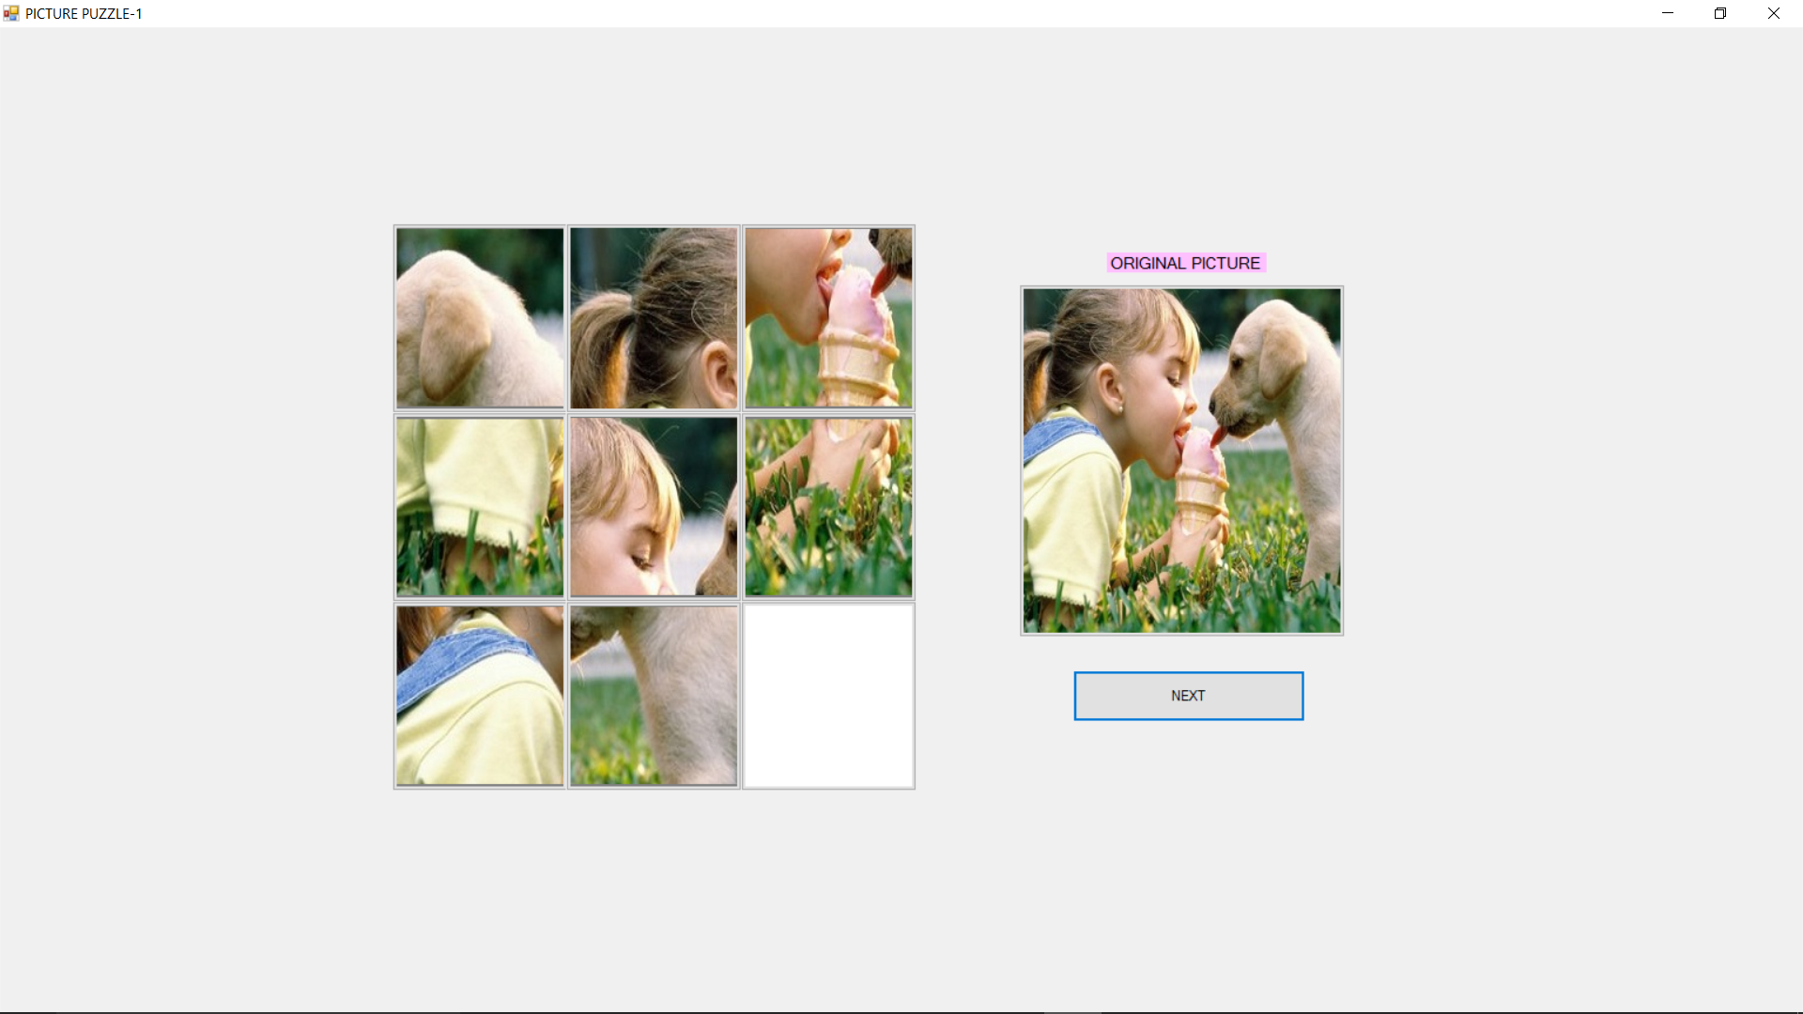
Snapshot 5.1: Snapshot displays 3*3 Picture Puzzle Game.
5.2 OUTPUT 2
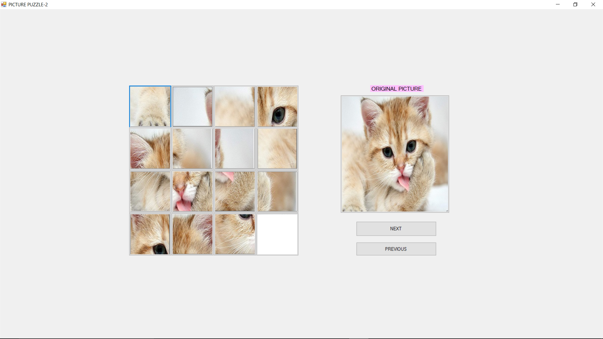
Snapshot 5.2: Snapshot displays 4*4 Picture Puzzle Game.

5.3 OUTPUT 3
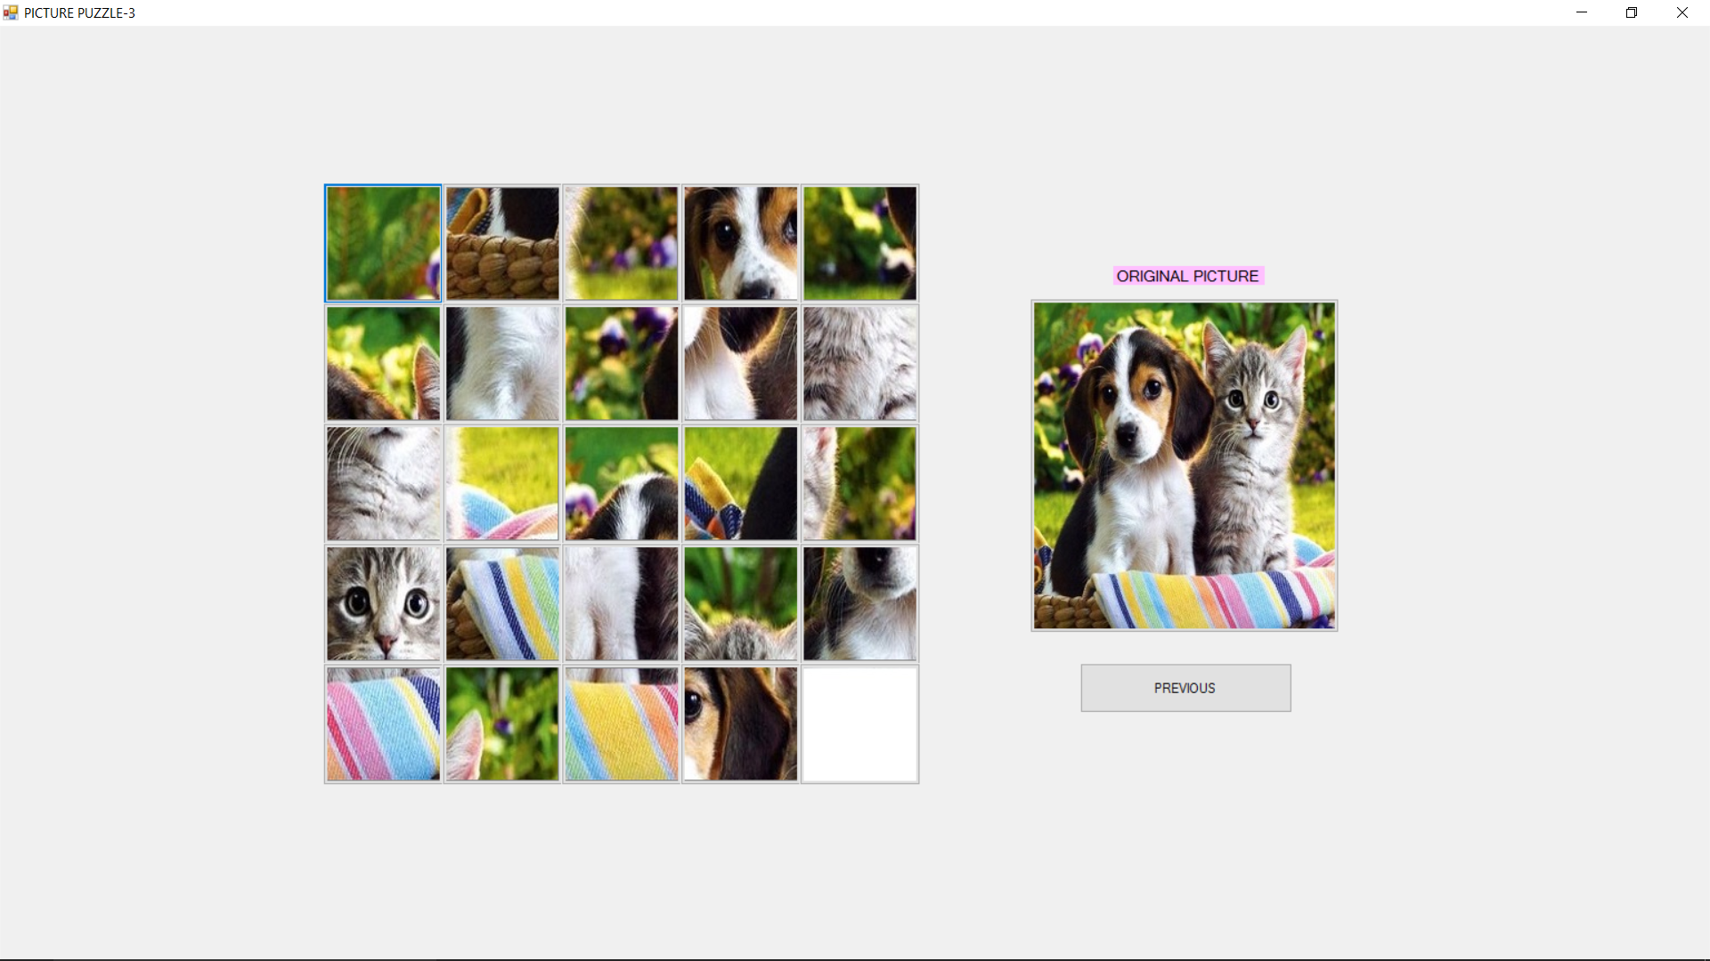
Snapshot 5.3 : Snapshot displays 5*5 Picture Puzzle Game.

CHAPTER 6
CONCLUSION AND FUTURE ENHANCEMENT
6.1 Conclusion
This project gave us the idea about, how we can use Microsoft Visual Studio for designing purpose and how we can implement the code for the buttons used in puzzle game. It also helped us in learning to create application using c# code. This project is used to implement 3*3, 4*4 and 5*5 Picture Puzzle Game efficiently.
6.2 Future enhancement
In future this system can be extended to the desired levels so that it can adapt to the changing technology and enhance its performance. The undo function can be included so that the user can retrieve back his/her moves. Additional players can be included to develop competition in between the players. Nowadays, Since most of the users play games on internet, We can also feature this game with internet connectivity.

REFERENCES

[1]https://github.com/A2andil/Projects/tree/master/C%23%20Projects/Picture%20Puzzle%20Project
[2]https://appgrooves.com/rank/game_puzzle/picture-puzzle-games/best-picture-puzzle-games#about-
[3] https://www.codeproject.com/Questions/273994/making-picture-puzzle-with-csharp

[4] https://iwantsourcecodes.com/image-puzzle-game-c-source-code

[5]http://freesourcecode.net/csharpprojects/40595/C%23-picture-Puzzle-Game-in- csharp#.XcrJPDMzZPY

